**Wind Integration in ISO New England**

**Final Project 1 Report**

EEEL 4220:

Energy System Economics and Optimization

Columbia University

Professor Bolun Xu

Fall 2024

By

Marguerite Généreux (mg4778)

Lukas Houpt (lkh2149)

Finn Laister Smith (fhl2120)

December 13, 2024

1. **Motivation:**

ISO New England aims to decarbonize its energy portfolio by incorporating up to 12,000 MW of wind capacity by 2030. This project explores the operational and economic implications of this integration of wind by running a unit commitment model to simulate various scenarios of wind generation capacity. Understanding the trade-offs between wind integration, operational costs, carbon emissions, and generator profit can help build a plan to recommend policies that balance sustainability and economic viability. Through the analysis, this report seeks to inform policymakers on effective strategies, including the use of carbon taxes, production tax credits (PTC) incentives for wind, and the inclusion of solar assets, to achieve a cleaner energy future while maintaining system reliability and cost efficiency.

1. **Method:**

This project is run as a unit commitment problem to analyze the integration of wind power into ISO New England's grid. The problem is formulated as a mixed-integer linear programming (MILP) model, where the objective is to minimize the total operational cost of generation while satisfying system demand, reserve requirements, and generator constraints. The objective function incorporates linear generation costs, startup costs, and a penalty for load shedding to ensure reliability. In order to test sensitivities and integrate as much wind in the system as possible, we ran the following scenarios, each with 5 wind integration cases (0 MW wind, 2000MW wind, 6000MW wind, 12000 MW wind, and 30000 MW wind to help test sensitivities around curtailment):

1. Simple Unit Commitment: with parameters given in the problem statement.
2. Carbon Allowance Scenario: following the [Regional Greenhouse Gas Initiative (RGGI)](https://www.rggi.org/sites/default/files/Uploads/Fact%20Sheets/RGGI_101_Factsheet.pdf) state by state carbon allowances.
   1. Across all generators in a state, the sum of generation (MWh) times each generator’s emissions (short tons per MWh) based on its fuel type[1] cannot exceed the state’s yearly limit, divided by 365 for relevance in a 7-day horizon.
   2. Ensuring that in day *k* of optimization, the optimized result does not lead to a required “stay-on” time for a generator in day *k+1*, multiplied by its emissions per MWh, does not exceed the state daily limit.
3. Production tax credits (PTC) incentives for renewables: adding revenue related to wind production to minimize curtailment.
4. Carbon Tax: Based on articles from Columbia Energy Policy[2], our proposed carbon tax rates are: **RFO**: $40/MW; **BIT**/**SUB**: $50/MW; **NG**: $15/MW. These rates reflect the relative carbon intensities of each fuel type.

The formal optimization formula or unique constraints for each of the scenarios is as follows:

1. Optimization formula:
2. Added constraint:
3. New optimization formula:
4. New optimization formula: +

To manage computational complexity, the analysis is performed sequentially for daily horizons (24 hours) with updated generator states. Key metrics such as total generation cost, wind curtailment ratio, generator profits, and average electricity price are used to evaluate each scenario. This methodology enables a comparison of operational trade-offs and the effectiveness of possible policy.

1. **Findings:**

The summary of scenarios run is in **Table 1** and **2** below. We compare each of these runs on the basis of total generation cost, wind curtailment ratio, average electricity price and generator profit for each wind integration case. We focus scenario comparisons on the 12000 MW case, as shown in **Table 2**.

**Table 1: Summary of Scenario 1 Results Over 7 Day Optimization**

|  | **Value** | **0 MW Wind** | **2000 MW Wind** | **6000 MW Wind** | **12000 MW Wind** | **30000 MW Wind** |
| --- | --- | --- | --- | --- | --- | --- |
| **Scenario 1: Simple Unit Commitment** | **Total Gen. Cost ($M)** | $ 75.0 | $ 68.5 | $ 59.6 | $ 53.8 | $ 39.7 |
| **Avg. Wind Curtailment** | N/A | 0% | 0% | 0.06% | 7.71% |
| **Avg. Electricity Price ($/MWh)** | $189.95 | $71.82 | $56.24 | $58.85 | $42.01 |
| **Generator Revenue($MM)** | $507.61 | $181.597 | $139.38 | $143.77 | $103.27 |
| **Total Generator Profit ($MM)** | $432.57 | $113.02 | $79.73 | $89.99 | $63.6 |

**Table 2. Summary of 12000 MW Wind Case Over 7 Day Optimization**

|  | **Value** | **Scenario 1 - Simple UC** | **Scenario 2 - Carbon Allowance** | **Scenario 3 - PTC (Total Gen. cost has PTC revenue subtracted)** | **Scenario 4 - Carbon Tax** |
| --- | --- | --- | --- | --- | --- |
| **12000 MW Wind Integration** | **Total Gen. Cost ($M)** | $ 53.8 | $2.565K | $ 35.5 | $76.6 |
| **Avg. Wind Curtailment** | 0.05% | 0.21% | 0.12% | 0.09% |
| **Avg. Electricity Price ($/MWh)** | $58.85 | $5766.54 | $50.16 | $75.64 |
| **Generator Revenue($MM)** | $143.77 | $13.85K | $122.83 | $183.42 |
| **Total Generator Profit ($MM)** | $89.99 | $11.3K | $87.36 | $106.82 |

Digging into Scenario 1 - Simple Unit Commitment:

* **Generation vs. Demand:** The system successfully meets the demand across all wind capacity scenarios, with no load shedding observed, as shown in **Appendix B.**
* **Wind Curtailment:** The results indicate no wind curtailment in the 2,000 MW and 6,000 MW scenarios, suggesting that the system can fully utilize the available wind generation under these capacities. In the 12,000 MW scenario, a small amount of curtailment is observed, due to the system's inability to fully absorb the additional wind generation during periods of low demand or high wind output, while respecting all generator constraints.
* **Cost Analysis:** The total generation cost decreases as wind capacity increases as shown in **Figure 1** below, driven by the zero marginal cost of wind power. However, the cost difference becomes less pronounced through day 7, which aligns with the decreasing wind contribution over time, as reflected in the wind capacity factor data shown in **Figure 2**.

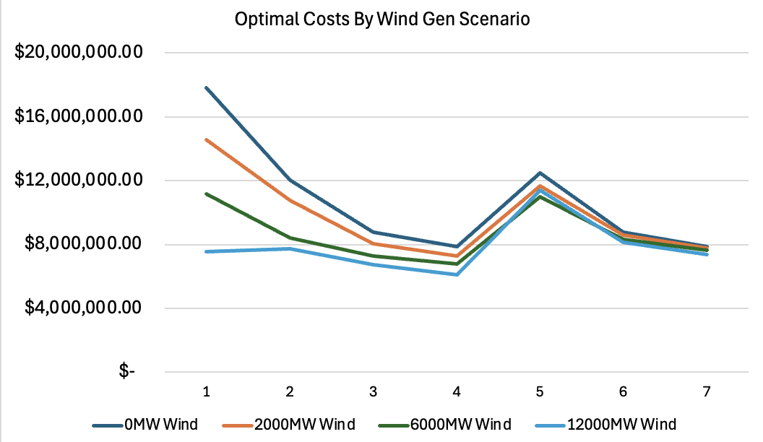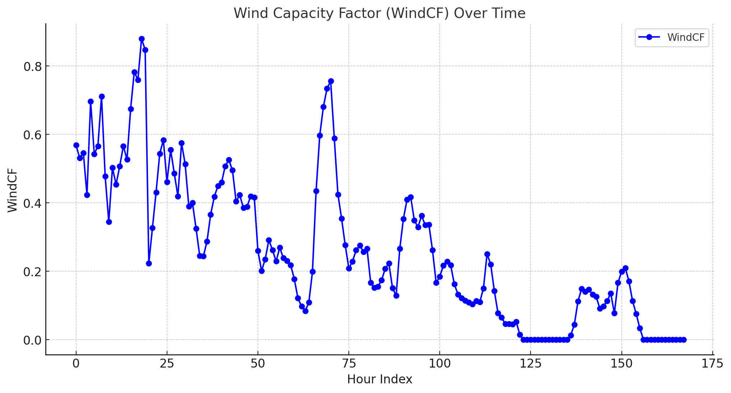

**Figure 1:** Scenario 1 Optimal Costs. **Figure 2:** Wind Capacity Factor.

* **Price Analysis:** The hourly average electricity price (**Figure 3**) peaks in the late morning and evening, which aligns with the interplay between wind capacity and system demand shown in **Figure 4**. As demand ramps, and wind capacity decreases around hour 10, prices spike. Similarly, around hour 21, when demand is high and there is a dip in wind, prices spike.

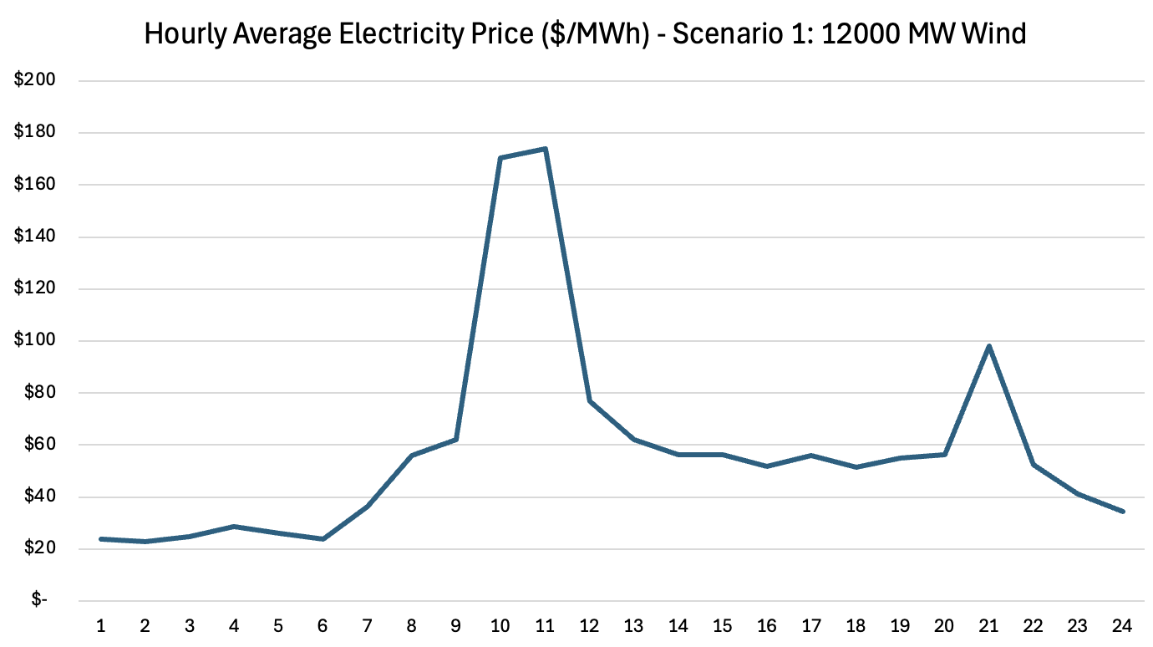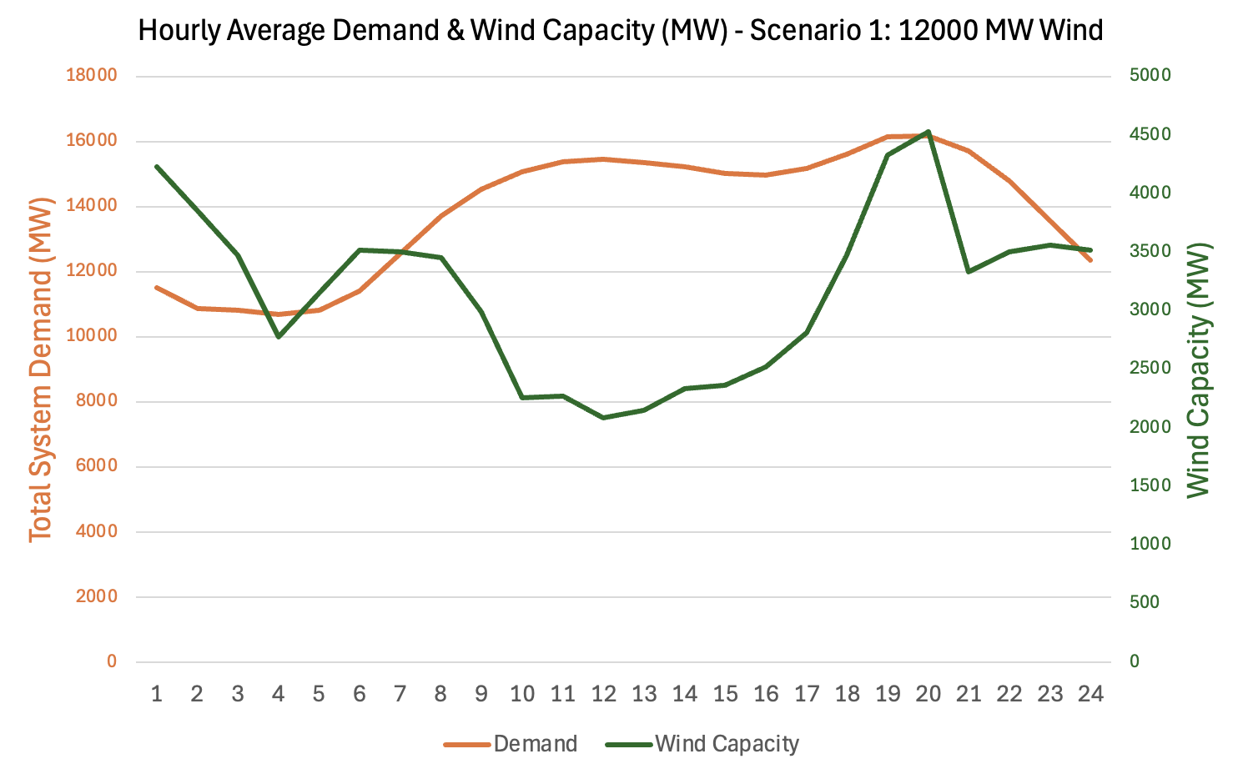

**Figure 3:** Hourly Electricity Price. **Figure 4:** Wind Capacity Factor.

* **Generator On/Off States:** The heatmaps of generator states in **Figure 5** highlight the reduced reliance on traditional generators as wind capacity increases. In the higher wind scenarios, coal and gas generators experience more frequent shutdowns or operate at reduced output levels, consistent with the priority given to wind as a zero-cost resource.

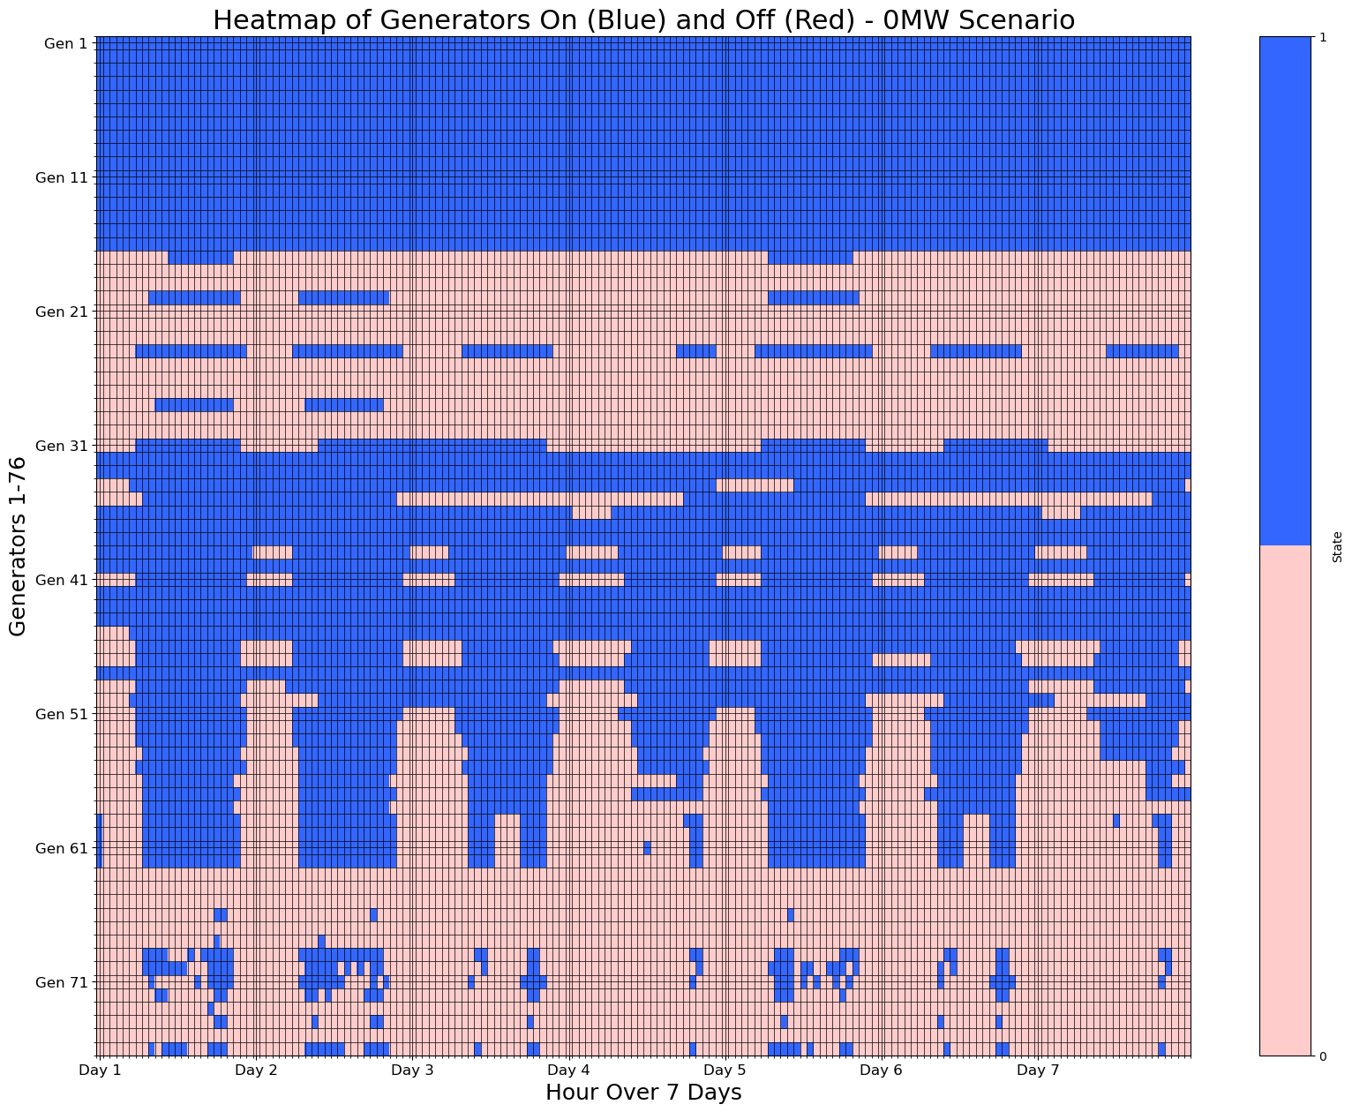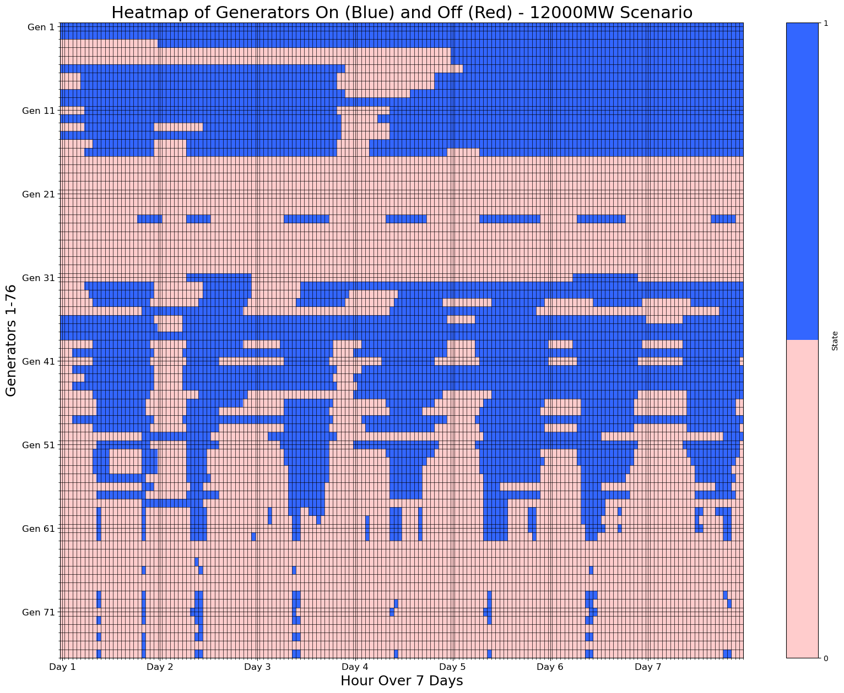

**Figure 5:** Generator On/Off States for 0 MW vs. 12,000 MW Wind Cases.

* **Ramping Analysis:**
  + Ramping increases as wind capacity increases, as power plants are forced to compensate for larger wind generation fluctuations. On the other hand, ramping is notably smaller in the Carbon Allowance and Carbon Tax scenarios than the Base and PTC scenarios for a given wind nameplate capacity value because thermal generators are discouraged altogether. See appendix for additional visualizations.

**Scenario Comparison:**

Moving forward from the base unit commitment problem in scenario 1, running scenarios 2-4 highlighted the following effects in the optimization for the 12000 MW Wind case:

1. **Generation cost:**

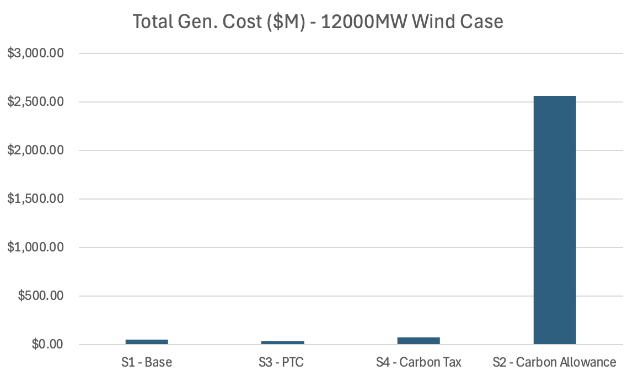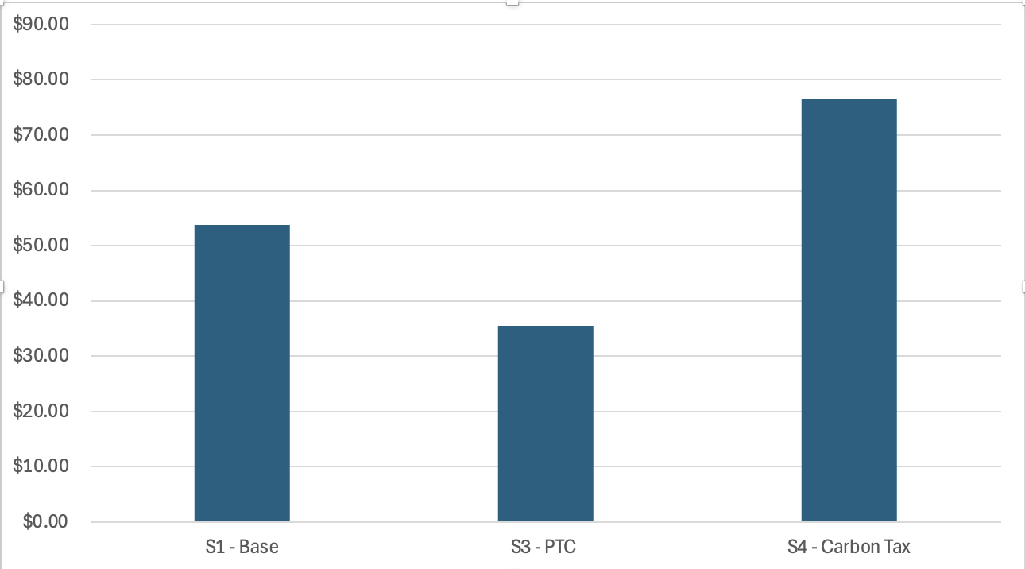

**Figure 7:** Total Generation Cost by Scenario.

1. **Curtailment Comparison: CO2 Emissions comparisons:**

|  |  |
| --- | --- |

**Figure 8:** Total Generation Cost by Scenario **Figure 9:** CO2 Emissions by Scenario

1. **Average price comparison:**

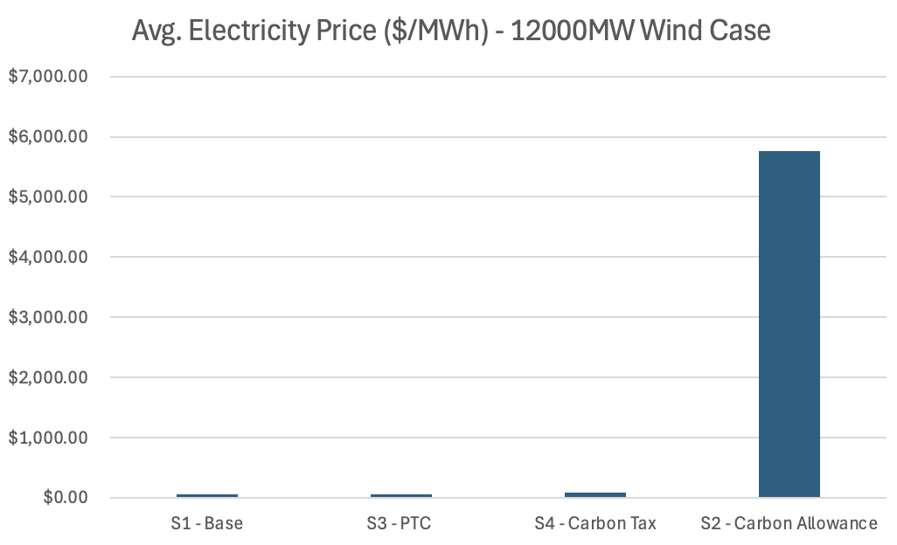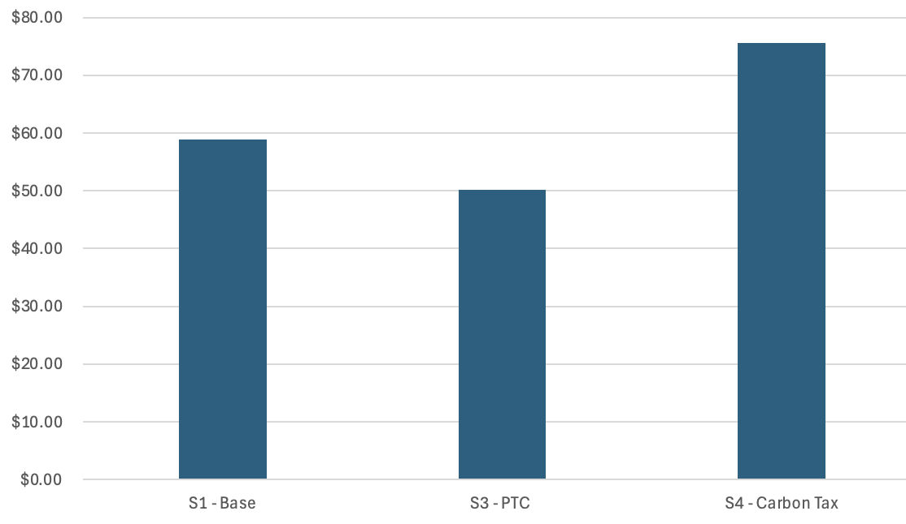

**Figure 10:** Average Price by Scenario.

1. **Profit comparison:**

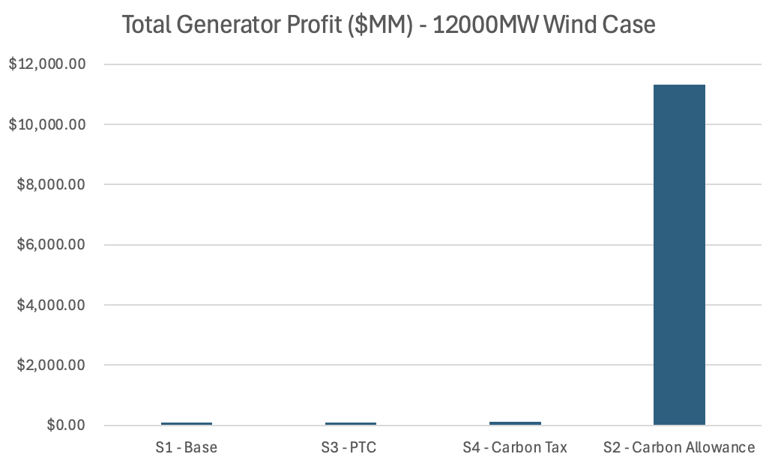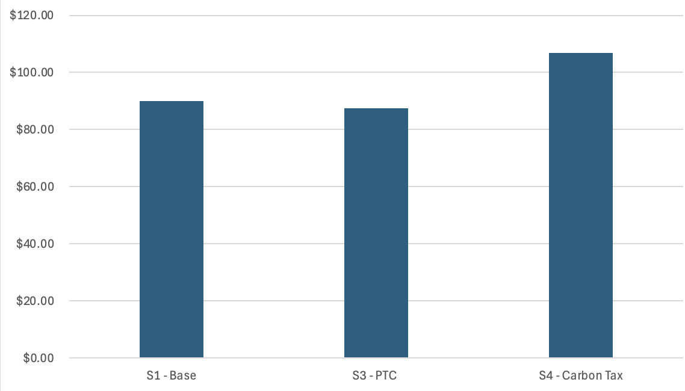

**Figure 11:** Total Generator Profit by Scenario.

**Comparison Summary:**

* **Scenario 2 (RGGI Carbon Allowance):** For days 1 the system works like other scenarios and the cost is comparable. In days 2-3 the amount of load shedding begins to rise, but once the wind went down (days 4-7) the load shedding is thousands of MW of generation in many hours, as we aren’t able to fulfill the demand with the available generators without violating the daily carbon cap constraints, given the lack of wind generation.

Given a 7-day optimization window, capping each state’s emissions by day may have created a system with unreasonably stringent constraints. In reality ISOs have a much longer time horizon over which to minimize carbon emissions generation, and this might allow them more flexibility given that they have 365 days over which to vary each state’s output.

We understand that there are seasonal/temporal variations in demand and renewable generation that would be factored into our system. The lack of these, combined with the short time horizon and daily optimization method, makes our implementation potentially too strict.

* **Scenario 3 (PTC):** Since the curtailment was already extremely low, adding the PTC didn’t lead to integrating significantly higher amounts of wind. Therefore the impact of this policy is minimal given the existing conditions in the system.
* **Scenario 4 (Carbon Tax):** Total generator cost went up, but because the marginal prices across the system were much higher as a result of adding costs associated with emissions, the generator revenue was also significantly higher. This added tax is designed to minimize the output of more inefficient generators, but because of the design of our system, that tax is shifted entirely onto consumers.

1. **Conclusions:**

From this analysis, the following insights emerge:

1. **Production Tax Credit (PTC):** Adding a PTC is the most effective way to lower average electricity prices. While it decreases generator profits, the overall system benefits through lower costs for consumers make it the most straightforward and immediate option to promote wind integration. At the same time, it doesn’t yield significantly different generation dispatch or emissions than the base case and an ITC may make more sense to promote wind development.
2. **Cap-and-Trade:** The daily emissions cap implemented in this analysis proved restrictive, particularly during periods of low wind generation, leading to significant load shedding and high prices. However, with a longer optimization window—such as an annual emissions budget—cap-and-trade could be more effective in balancing emissions reduction and reliability.
3. **Carbon Tax:** While a carbon tax encourages cleaner generation by penalizing high-emission sources, its current implementation results in higher electricity prices for consumers, as the tax burden is shifted entirely onto them. Addressing this issue to avoid significant price increases is essential for its viability.

The analysis showed limited success in integrating more wind generation, because curtailment was low initially, and because wind availability dropped significantly in days 4–7. With consistently higher wind generation across the optimization period, these policies might have shown greater effectiveness in reducing costs and emissions while integrating more renewables.

Overall, the PTC offers the most immediate benefits for consumers, while cap-and-trade could be transformative with a longer planning horizon. The carbon tax remains a promising tool if consumer cost impacts can be mitigated. Carbon emissions reductions appear achievable only at a very high cost.

**Appendix:**

The following visualizations can be found in the Appendix

* A: Heatmaps of Generator On/Off States:
* B: Total Generation vs Demand:
* C: Total Wind Capacity & Wind Generation (curtailment)
* D: Checking Curtailment Logic With Extra High Wind Scenario (30GW)

**A: Heatmaps of Generator On/Off States - Scenario 1 Simple Unit Commitment:**

****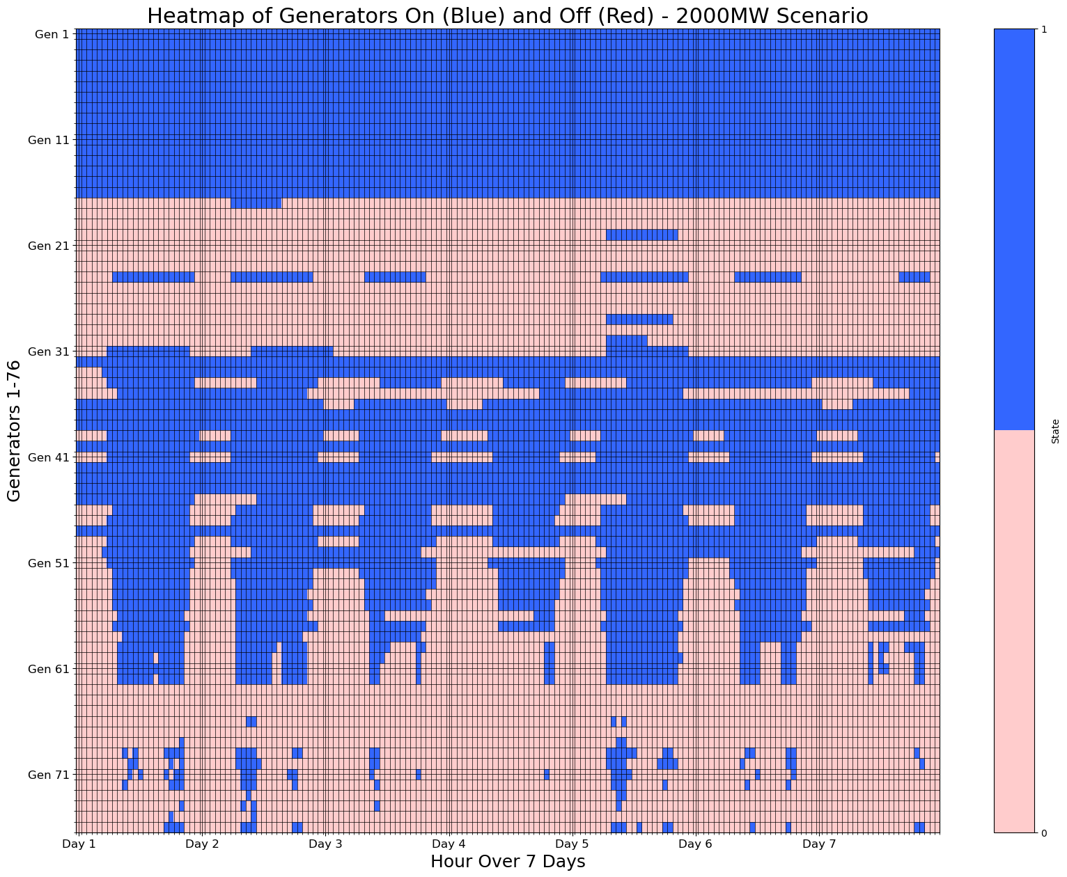

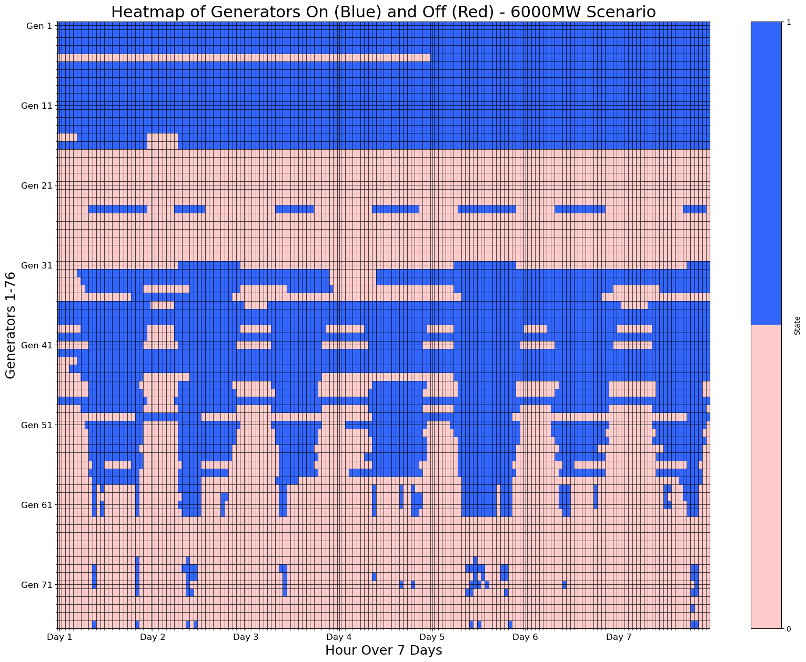****

**B: Total Generation vs Demand - Scenario 1 Simple Unit Commitment:**

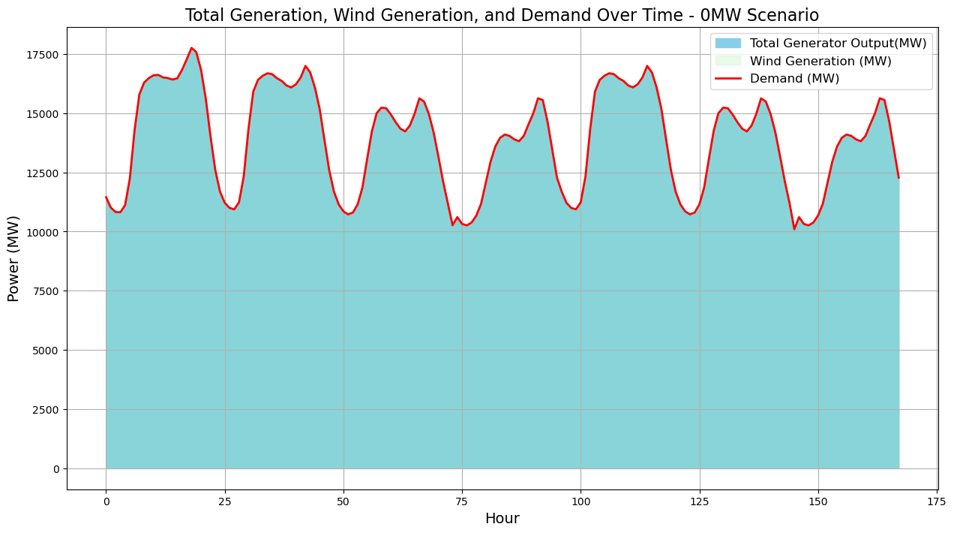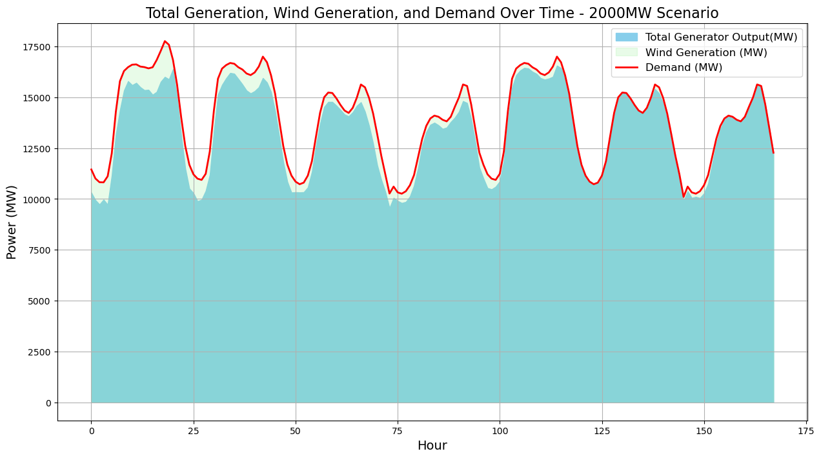

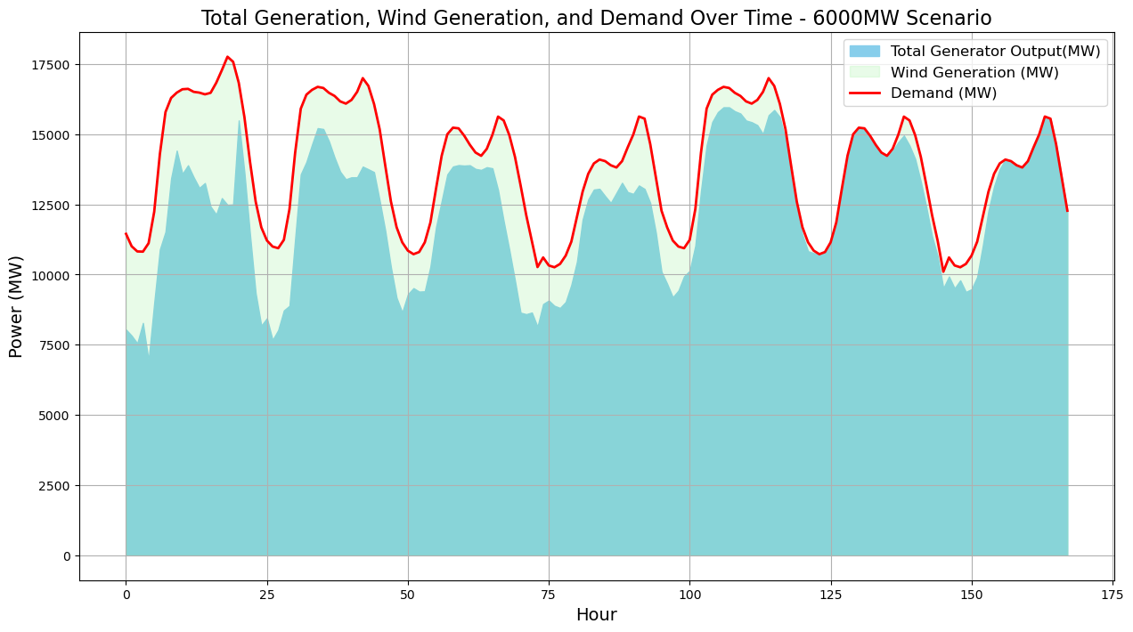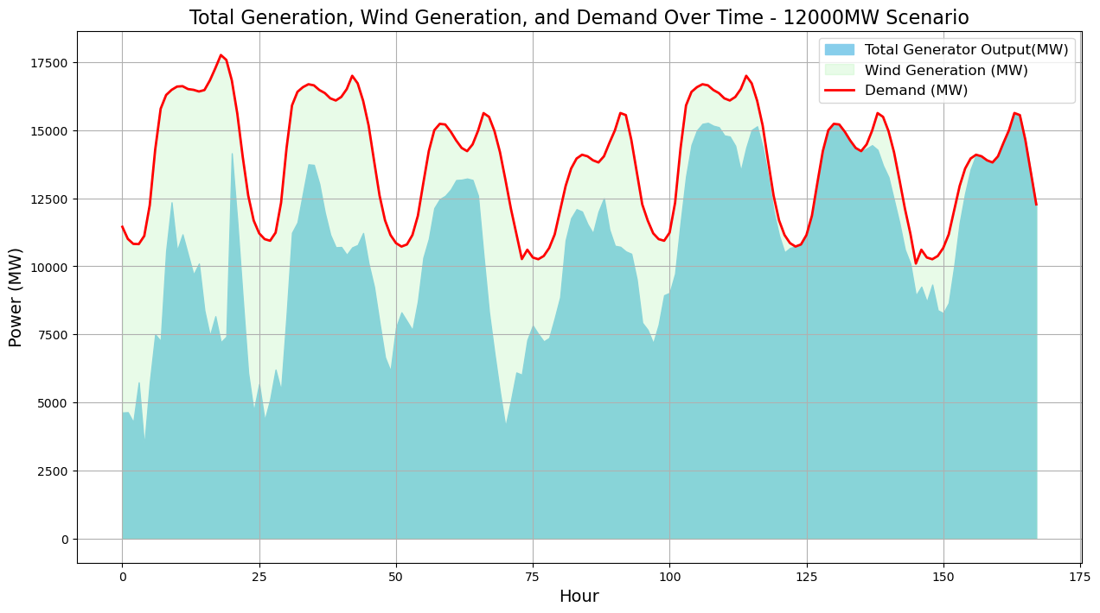

**C: Total Wind Capacity & Wind Generation - Scenario 1 Simple Unit Commitment:**

**No Curtailment in 2GW, 6GW Case, Little Bit of Curtailment in 12 GW Case**

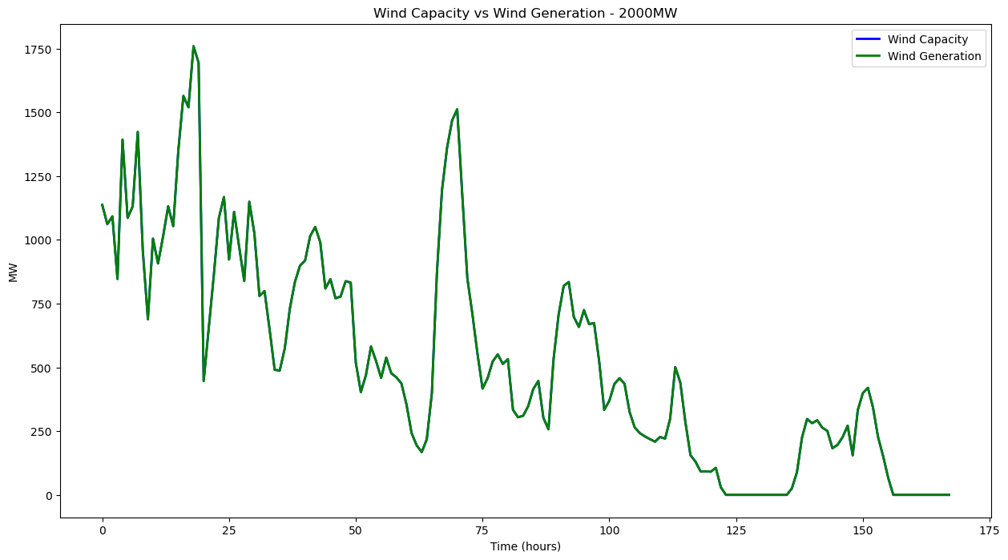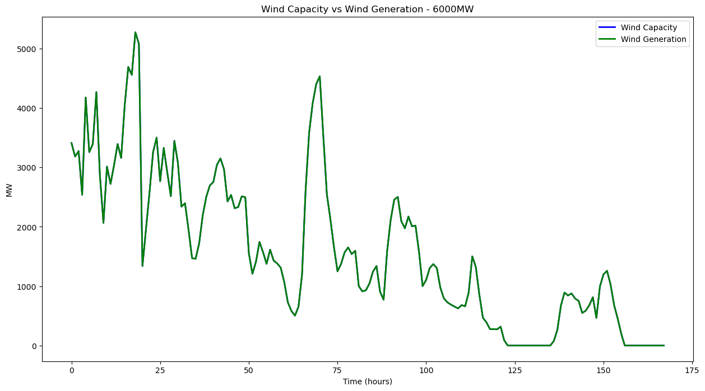

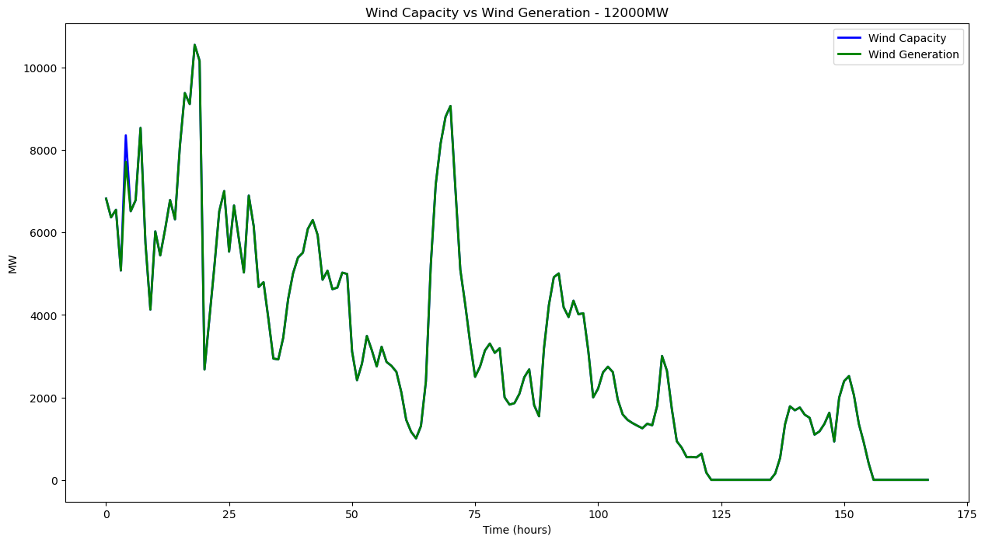

**D: Checking Curtailment Logic With Extra High Wind Scenario (30GW) - Scenario 1 Simple Unit Commitment: : It works!**

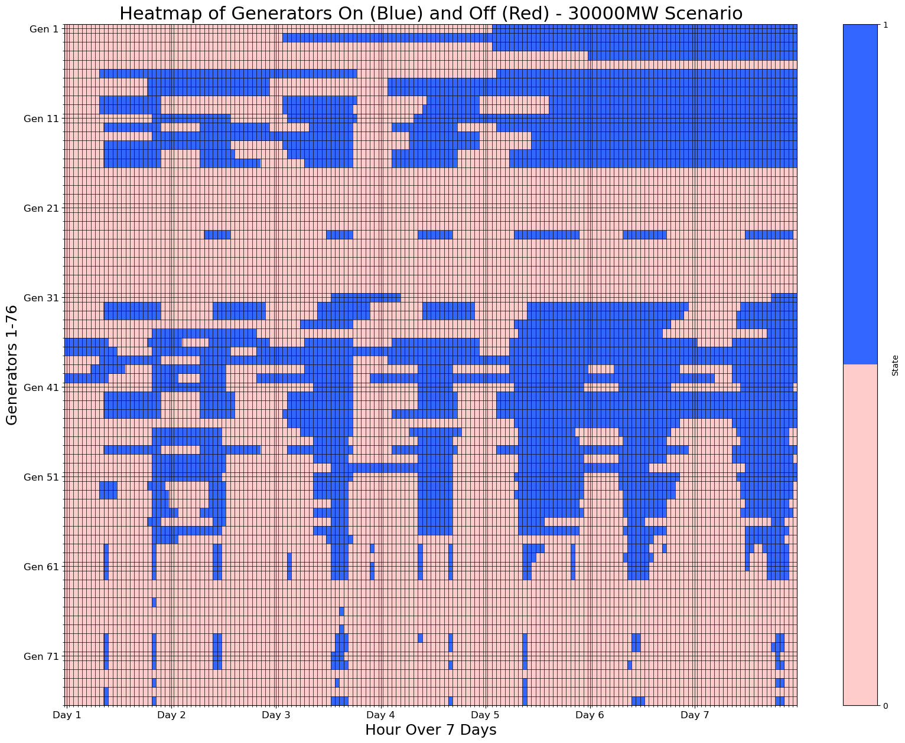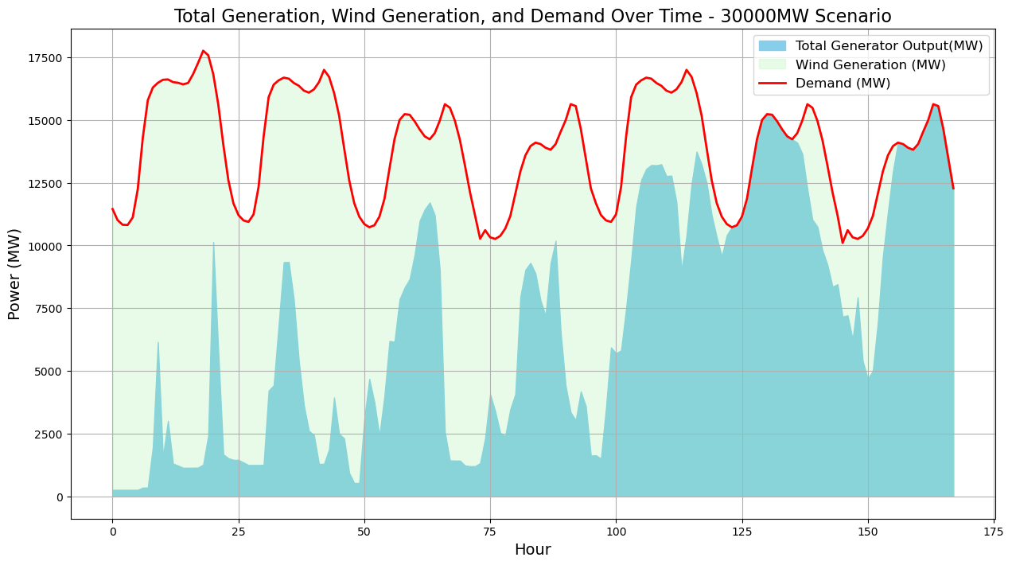

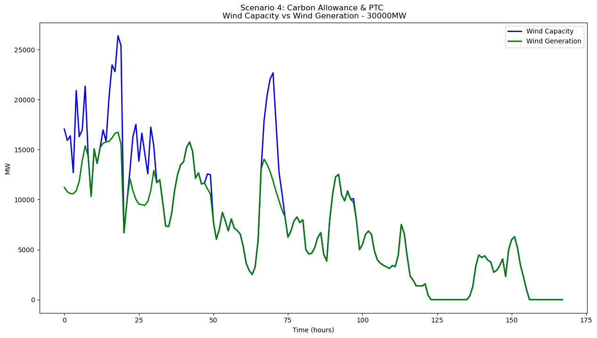

**F: Heatmaps of Generator On/Off States - Carbon Allowance & PTC Combined Scenario:**

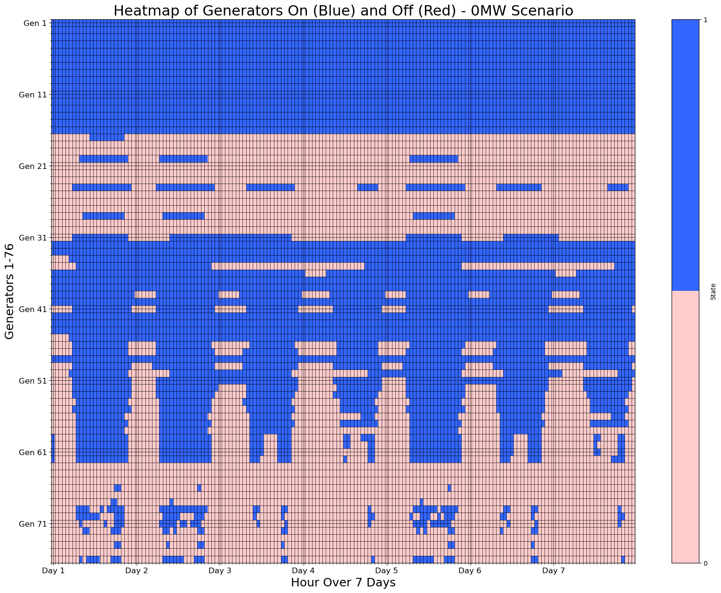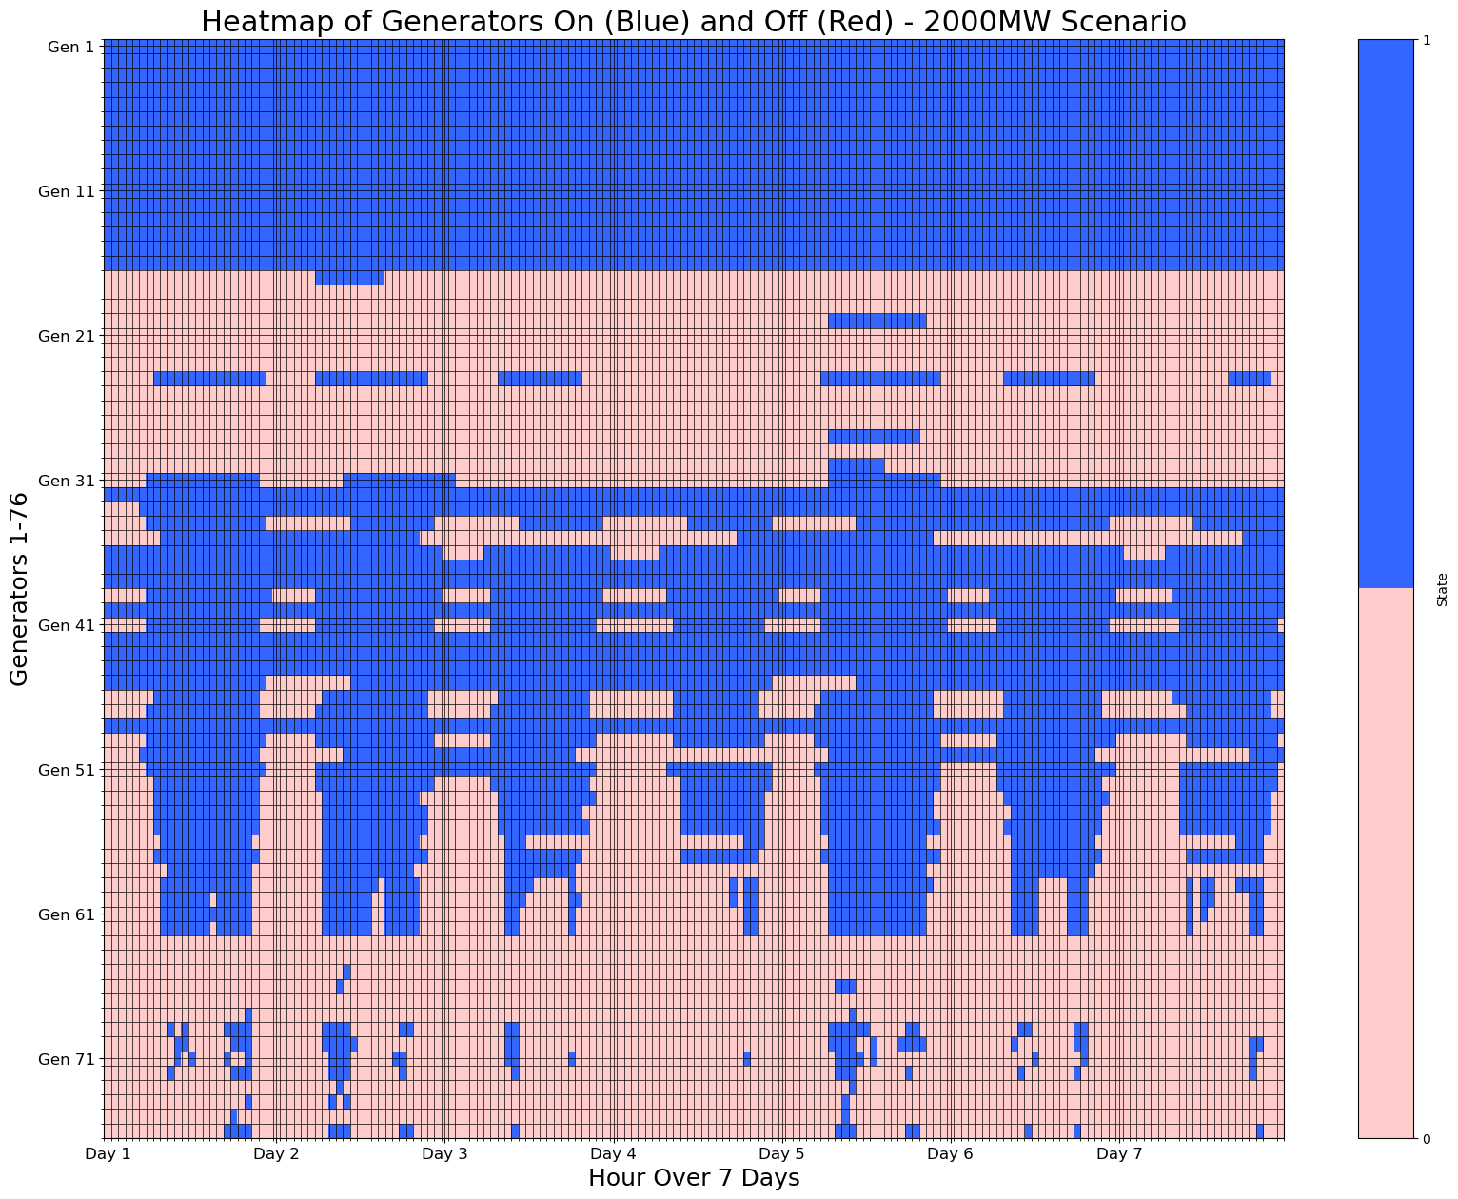

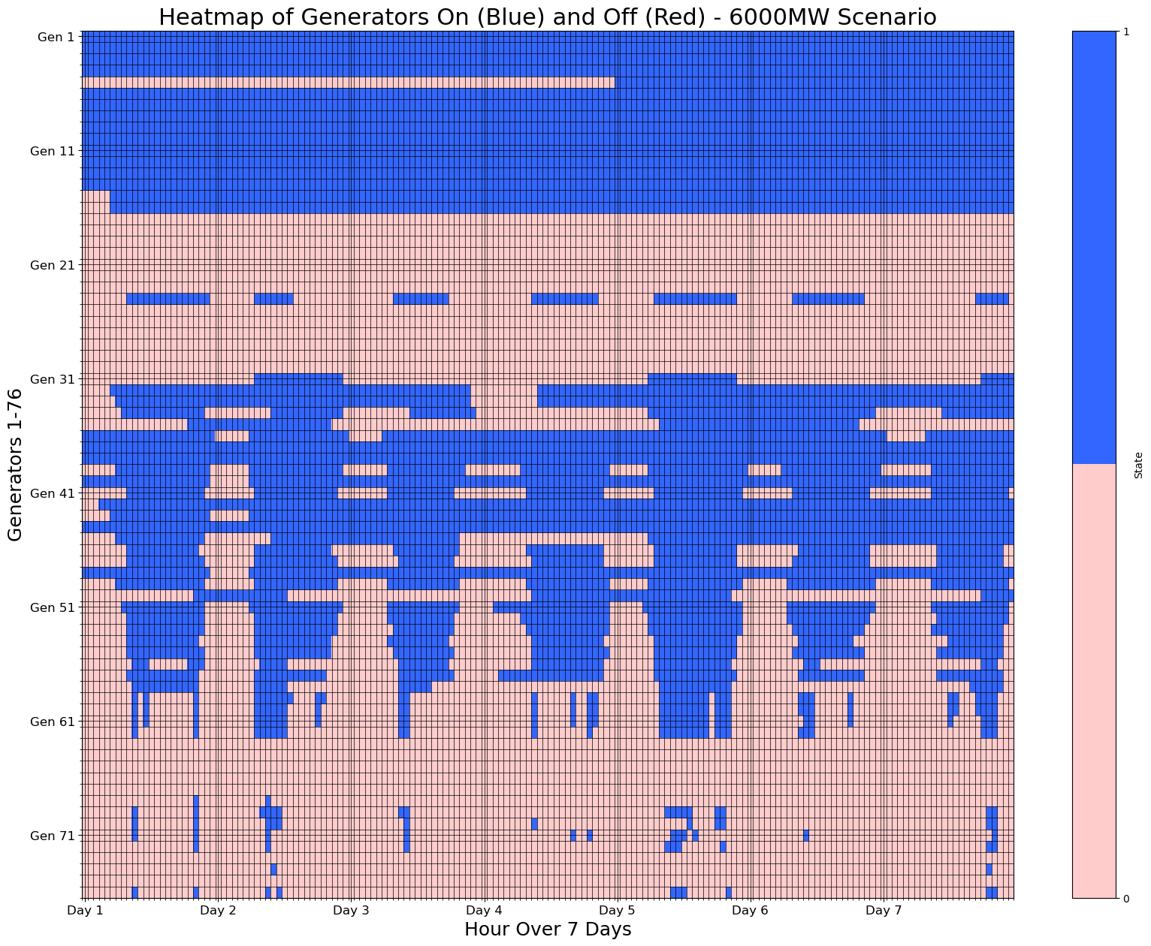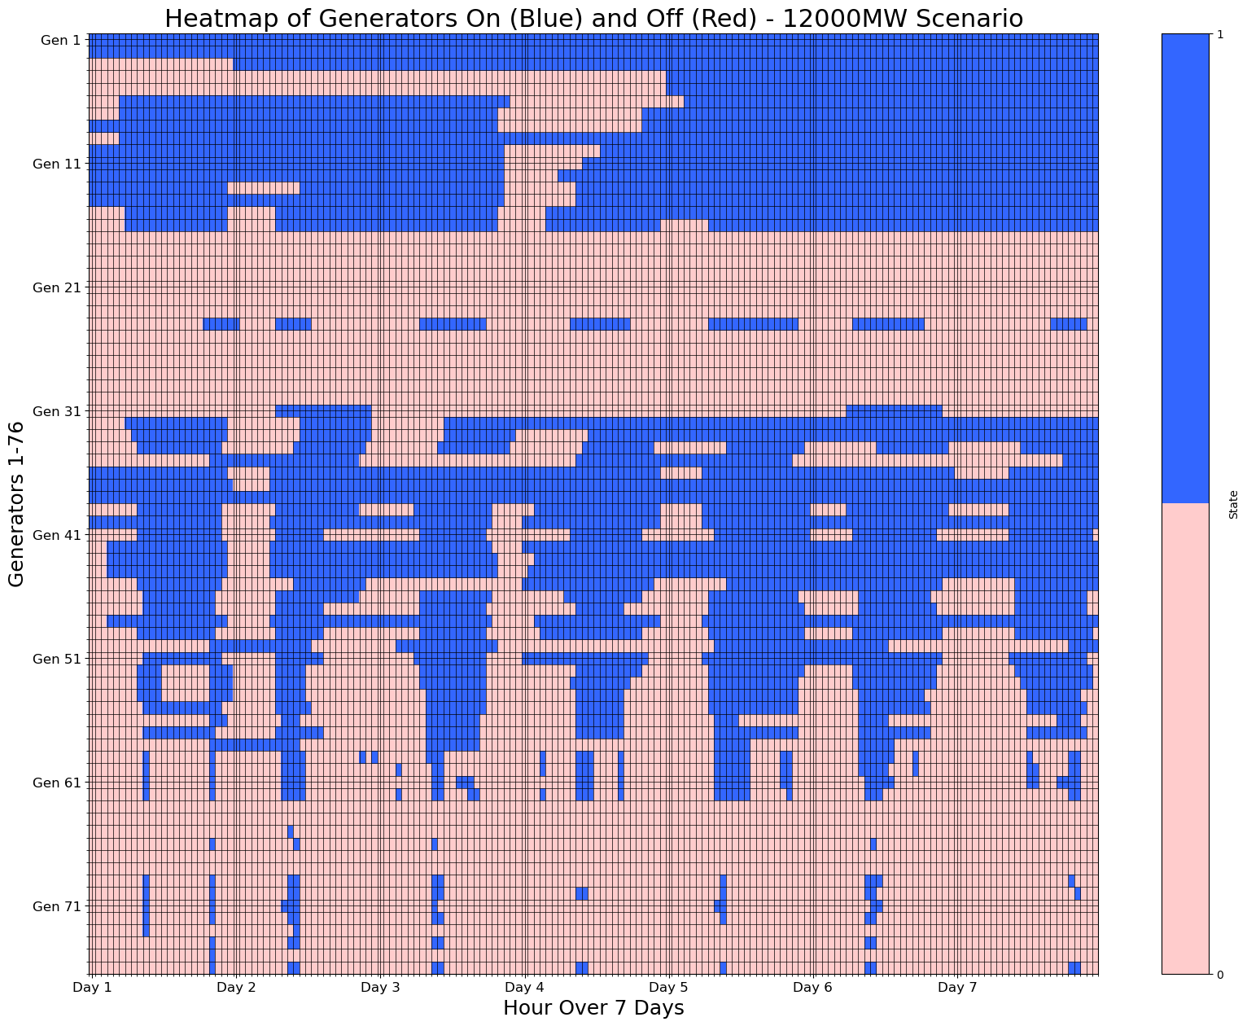

**G: Total Generation vs Demand - Scenario 3 Carbon Allowance & PTC Scenario:**

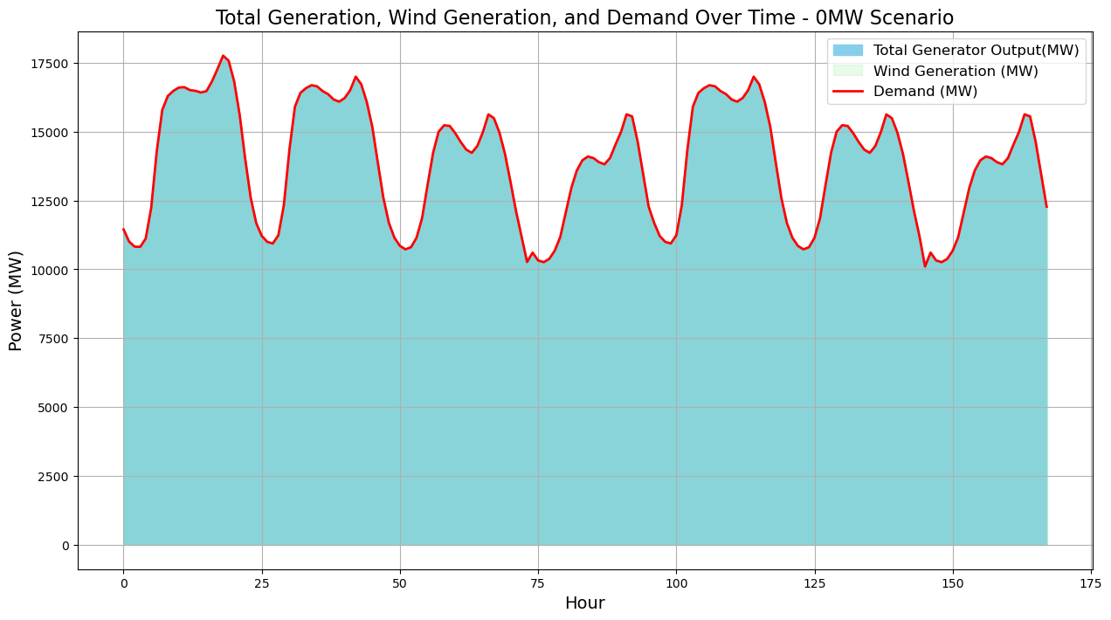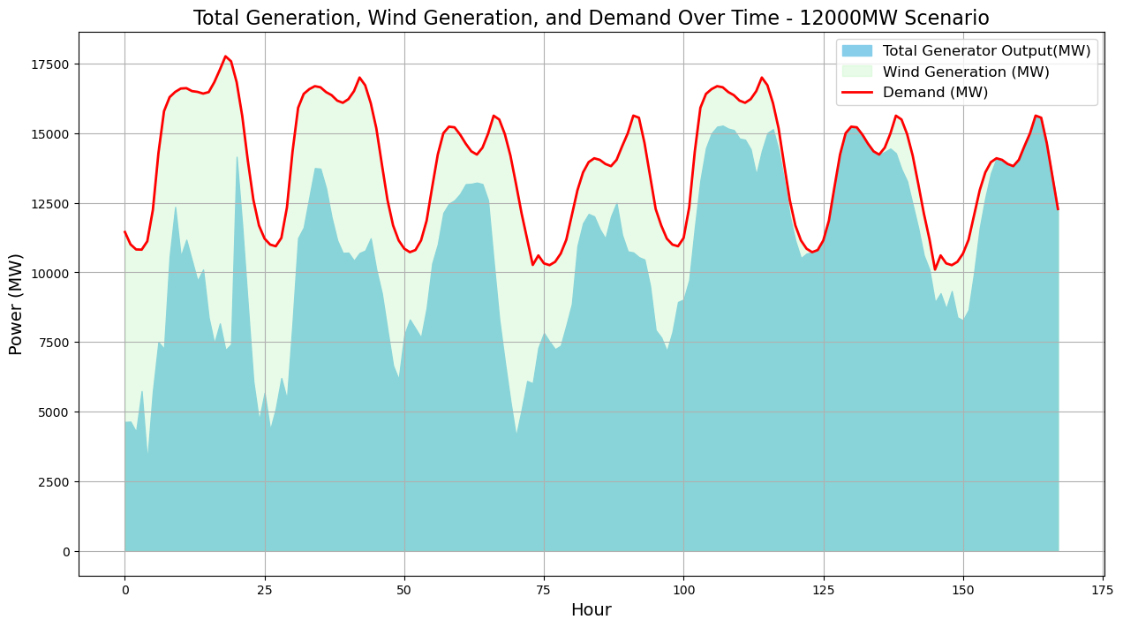

**H: Total Wind Capacity & Wind Generation - Scenario 3 Carbon Allowance & PTC Scenario:**

 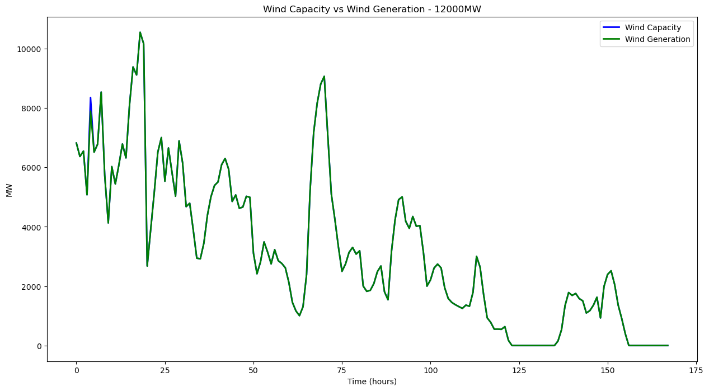

**I: 30 GW Extra High wind - Scenario 3: Carbon Allowance & PTC Scenario:**

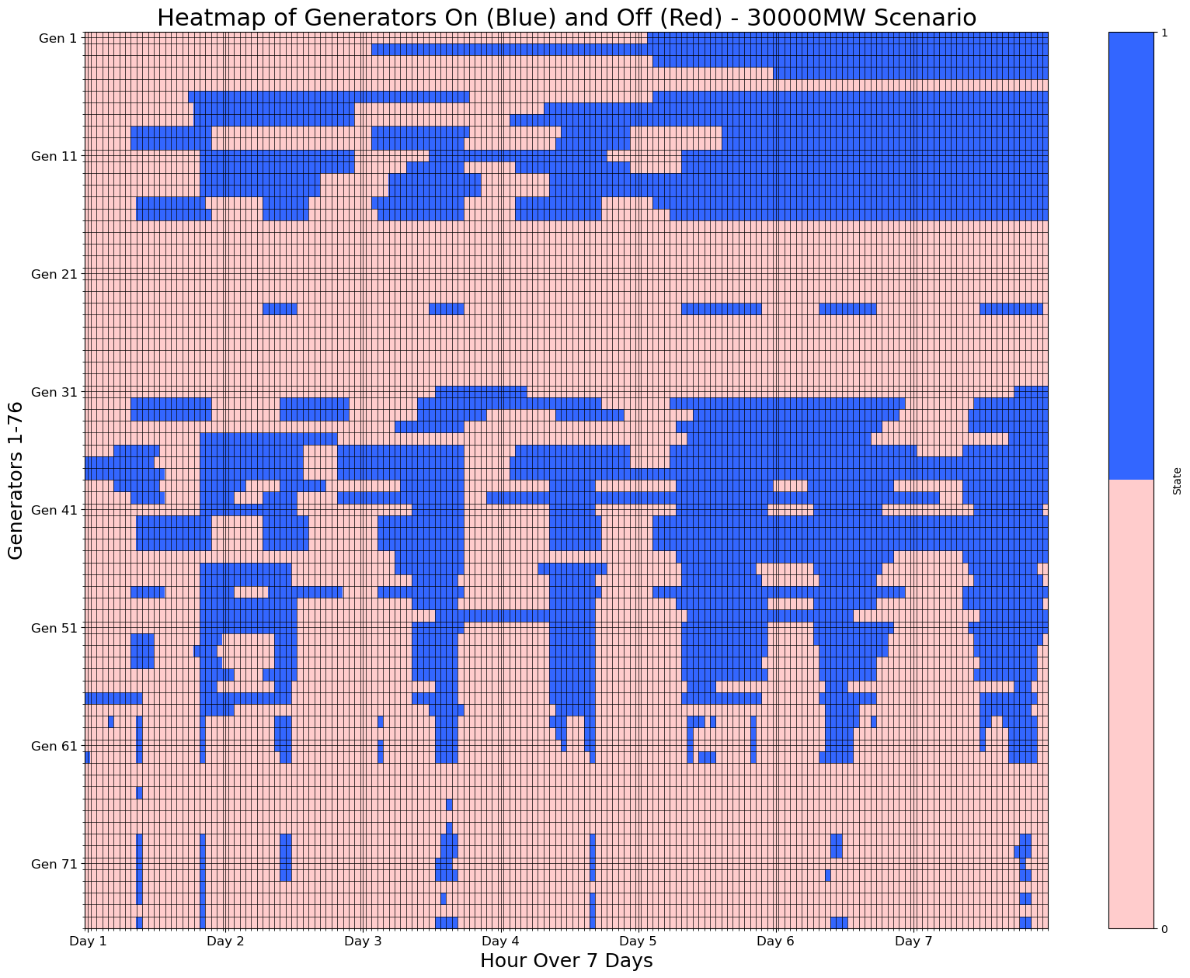

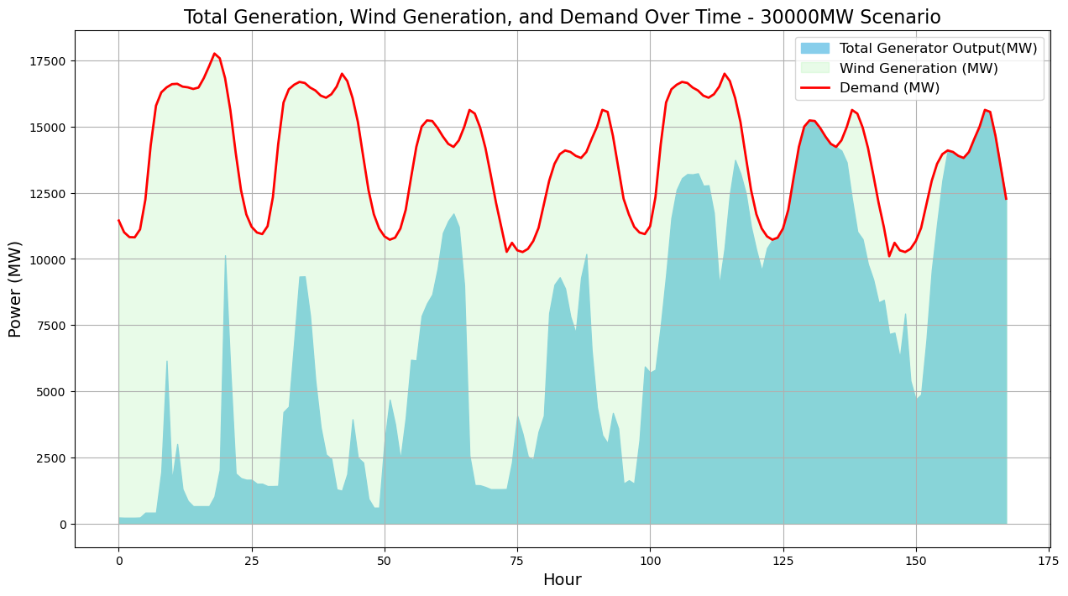

**J: 12 GW - Scenario 2: Cap and Trade - hourly demand, slack, wind generation & g:**

[**Scenario 2 Daily Demand & Gen**](https://docs.google.com/spreadsheets/d/1yR4HZ-abGrTDctXEdeGeb-hI-r1Qqih_UqppVr7QN_4/edit?usp=sharing)

**K: Compiled Daily Optimization Costs Spreadsheet:**

[**Final Results Summary**](https://docs.google.com/spreadsheets/d/1h1WDF_MgopJjefG1KEueo38IPve2qZLndozniGxZDW0/edit?usp=sharing)

**L: Final data files directory:**

[**Marginal_Cost_Outputs**](https://drive.google.com/drive/folders/1Jo3RqPeJ0HOnJrapxTuDrGaUnMIF4obz?usp=sharing)

**M: Additional data used for constraints**

[CO2 Allowances](https://drive.google.com/file/d/1c6vHS4XJ57A1b9JFoT5kKbhuNHUmh3Lf/view?usp=drive_link) (2023)

[Fuel Heating Values](https://drive.google.com/file/d/1FF99hQLHg9_d3_Z2igKT76NuuPcSX15N/view?usp=drive_link)

[Fuel Type Mapping](https://drive.google.com/file/d/1p4guZwUsm45bdFm_YT48UksKRrs4lkec/view?usp=drive_link)

[Emissions by fuel type](https://drive.google.com/file/d/1dDKdPLJzGUwoFCS7iGwxcSR6fC3SW0lv/view?usp=drive_link)

**N: Hourly Emissions Formula and Findings**

Formula: *

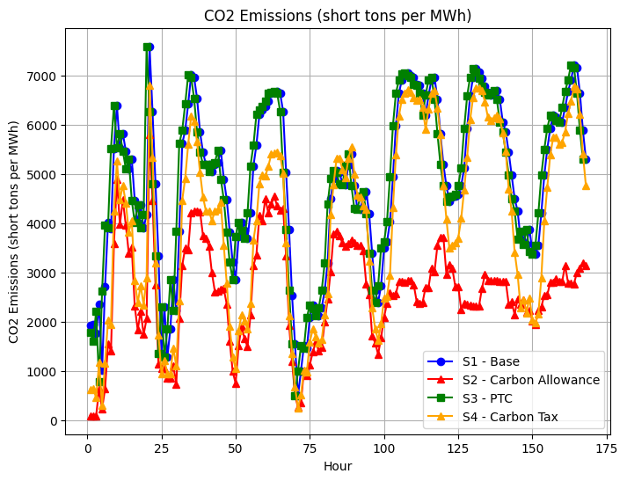

*The Base and PTC scenarios show nearly identical CO2 Emissions, while the Carbon Tax scenario and more so the Carbon Allowance scenario demonstrate greater emissions reductions.*

**O: Ramping**

Generator ramping is seen increasing for higher wind capacities (2GW < 6 GW < 12GW), and generator ramping is seen smaller for the Carbon Allowance and Carbon Tax scenarios than for the Base and PTC scenarios.

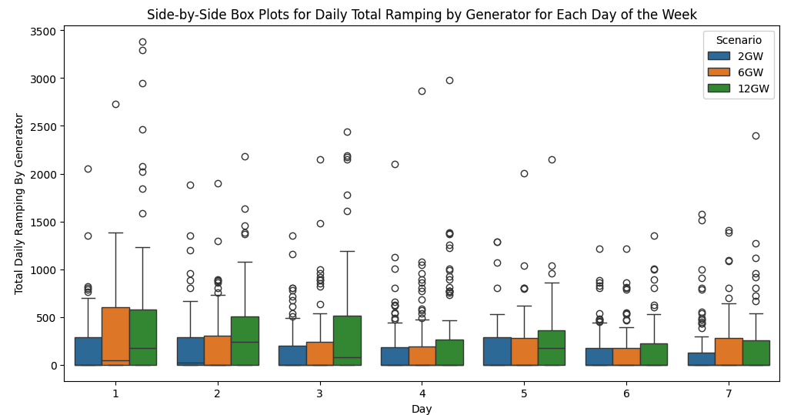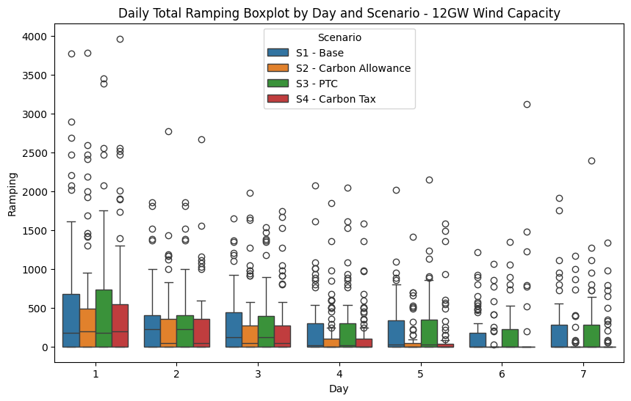

1. EIA showed that “All Other Fuels” (includes nuclear) emitted 0.43 short tons of CO2/MWh, but we adjusted this to near 0 to better reflect the emissions of nuclear plants, since no other fuel types are used.
2. [What you need to know a Federal Carbon tax in the United States](https://www.energypolicy.columbia.edu/publications/what-you-need-to-know-about-a-federal-carbon-tax-in-the-united-states/), 2019